**Name:** Omar Yasser Mahmoud

***Sec****:* 25

**ID:** 551

**Topic**: Mobile computing

Github-link: <https://github.com/omar-yasser-222/HTML-project-repository>

Github-page[puplished-wepsite] : https://omar-yasser-222.github.io/HTML-project-repository/

Application Brief: As mobile computing has been developed for decades, a new model for mobile computing, namely, mobile cloud computing, emerges resulting from the marriage of powerful yet affordable mobile devices and cloud computing. In this paper we survey existing mobile cloud computing applications, as well as speculate future generation mobile cloud computing applications. We provide insights for the enabling technologies and challenges that lie ahead for us to move forward from mobile computing to mobile cloud computing for building the next generation mobile cloud applications. For each of the challenges, we provide a survey of existing solutions, identify research gaps, and suggest future research areas. Keywords Mobile computing · Cloud computing · Mobile cloud computing · Mobile cloud application

# Screenshots:

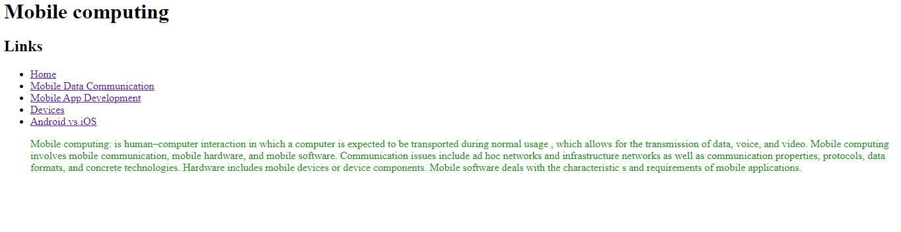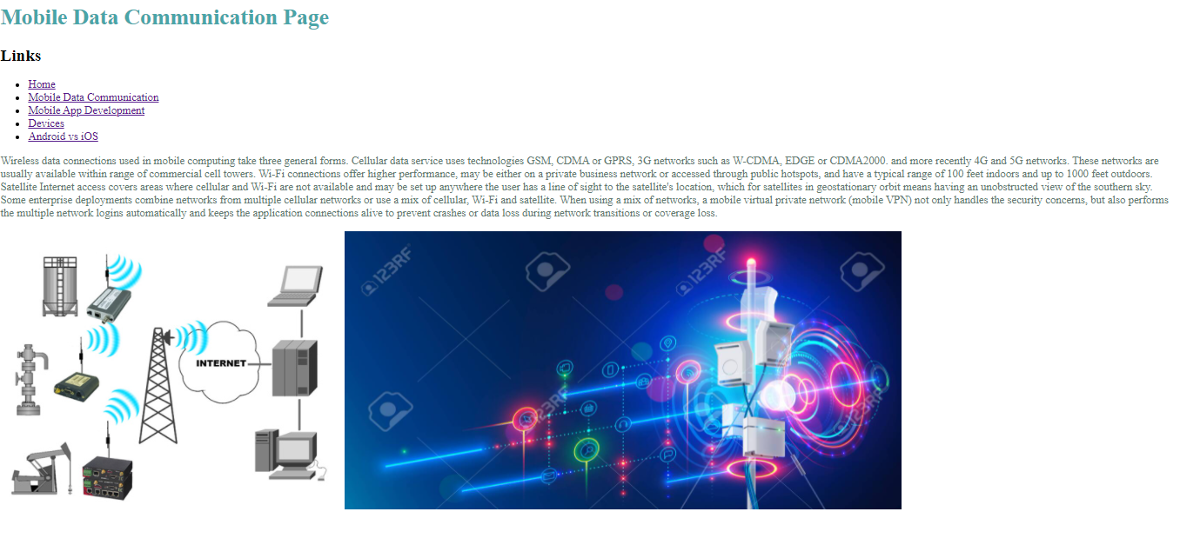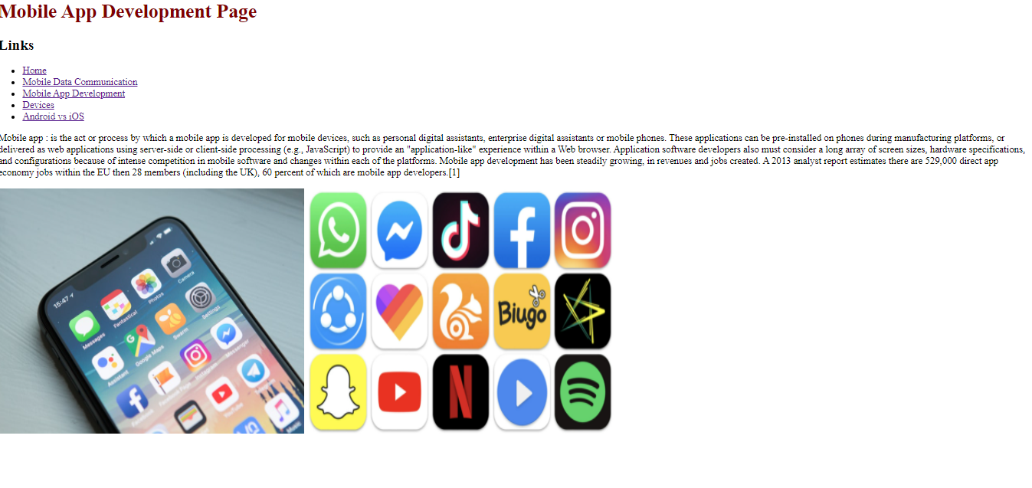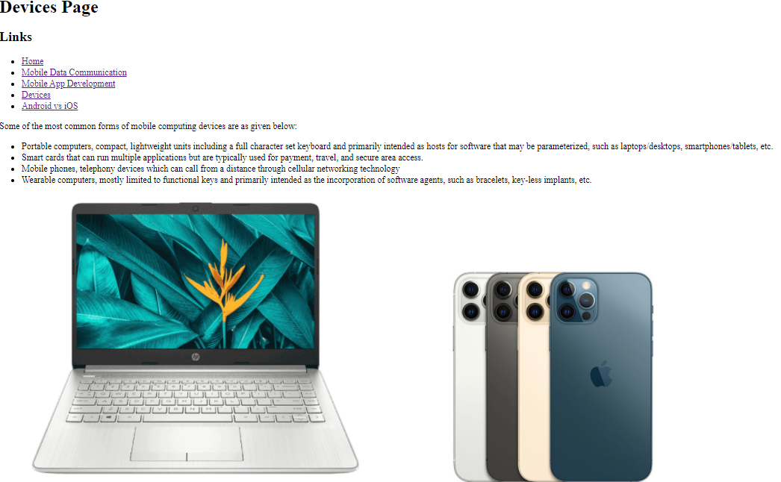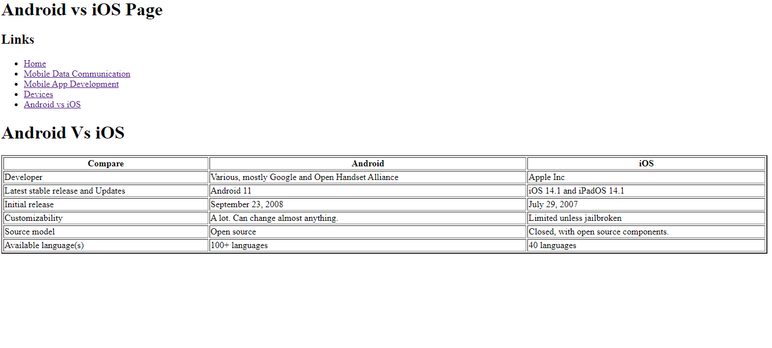

## Source code:

